Iteration 3 Use Cases Installation Package

**Use Case Installation**

**Note: If at any point the user selects cancel from the main screen, the program will exit**

1. System displays the installation screen

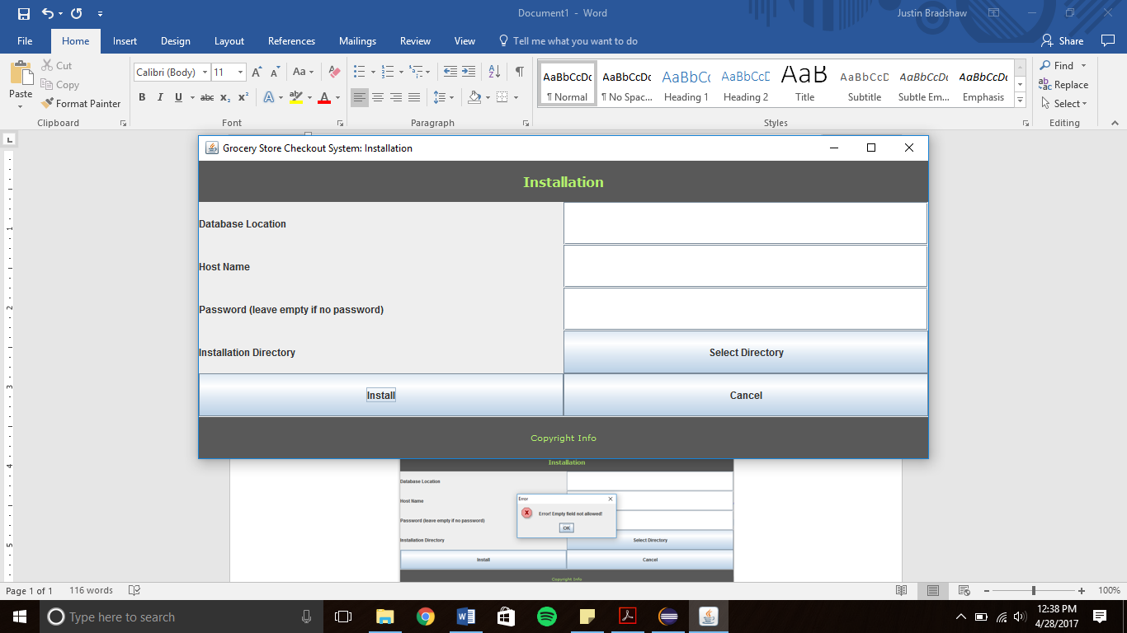

1. User enters the database location, host name, and password
2. User presses the select directory button
3. The File System directory is displayed
   1. If the user selects a directory, the directory is stored
   2. If the user selects cancel, no directory is stored

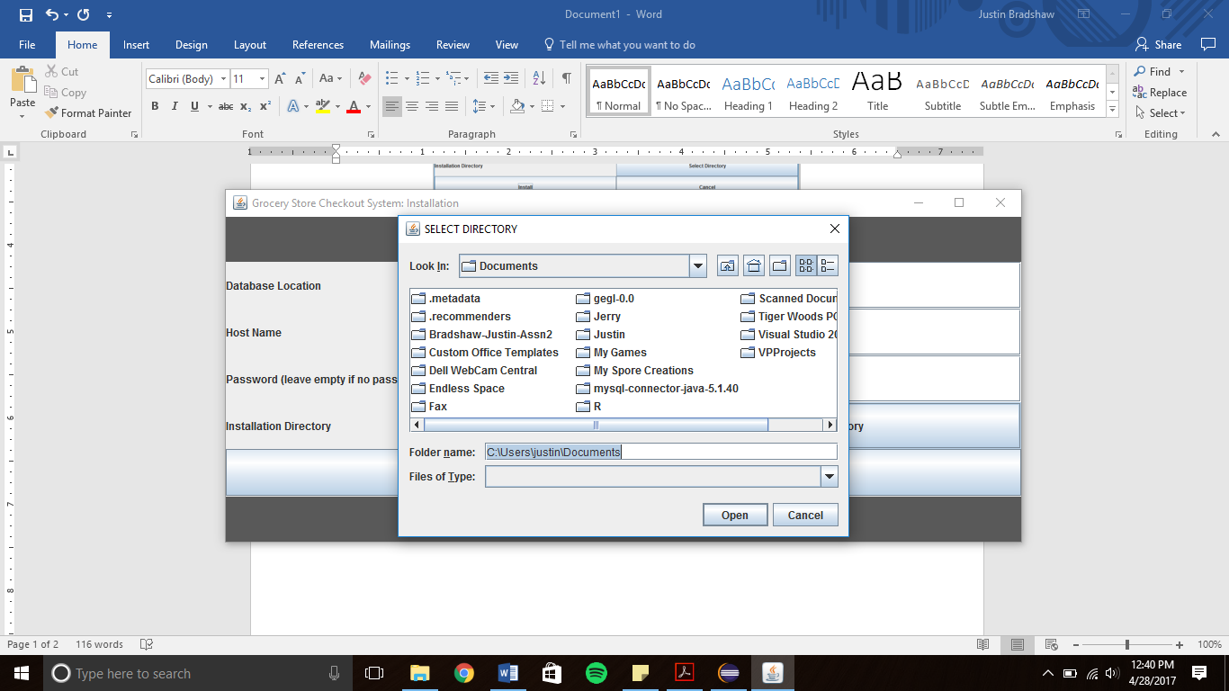

1. The user selects the install button
   1. If they have left any entries empty other than the password, an error message is displayed (if empty directory, empty directory error message is displayed)

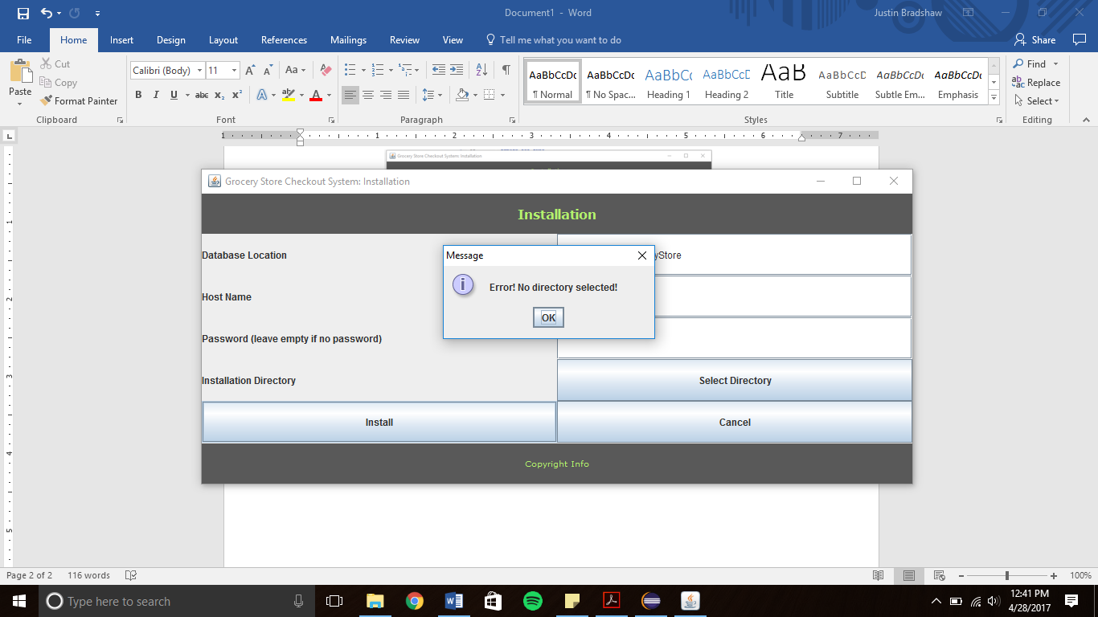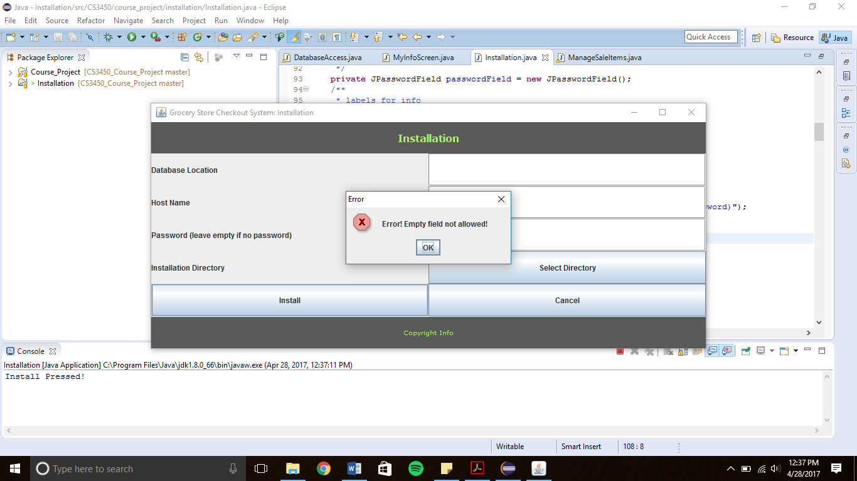

1. If all entries are valid, the installation process completes and a confirmation message appears

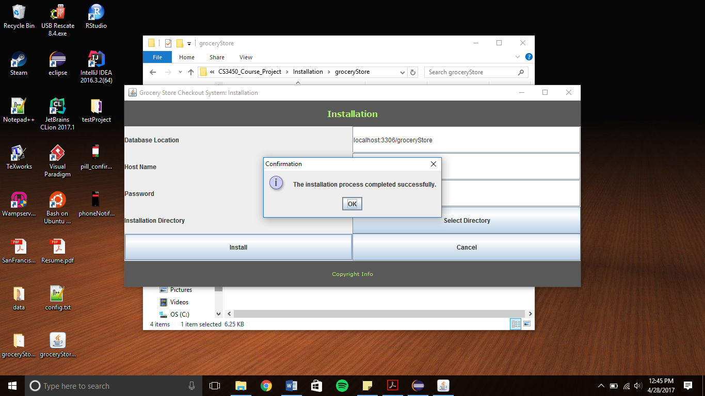

1. 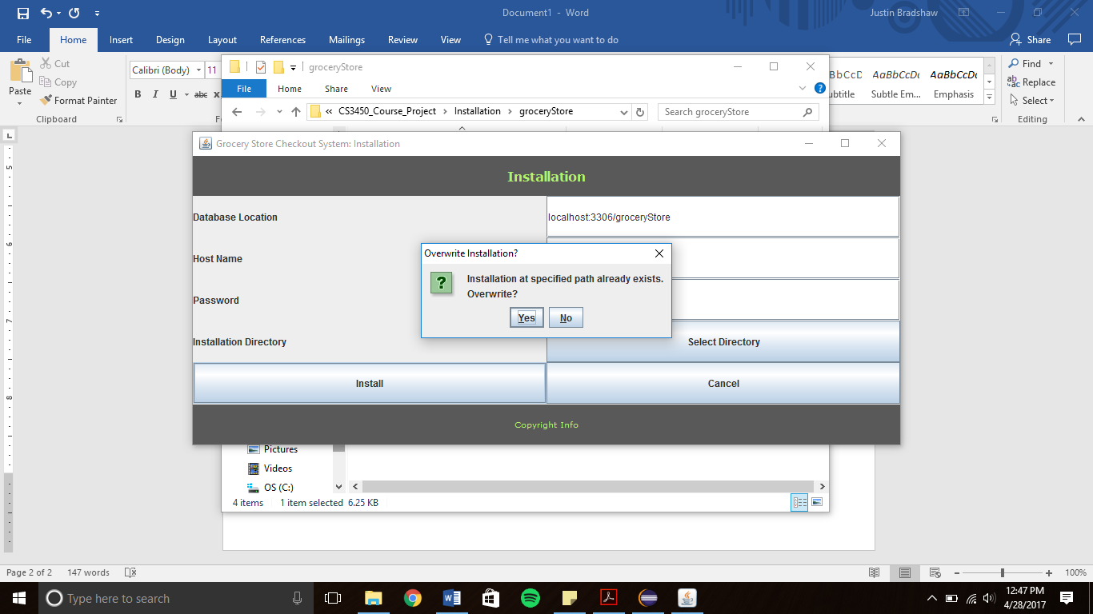If the program already exists at the installation location, the user may select whether or not to override the current installation.